

The "I Will’s” of Pride (Isaiah 14:13-14; Ezekiel 28:11-17)

Main point: God hates pride. Pride separates us from Him.

Key Verse: In his pride the wicked does not seek Him; in all his thoughts there is no room for God. - Psalm 10:4 NIV

Materials: Magnets; Proud/Humble Card Game

Personal Connection
- Leader, begin to slightly “brag” about an area in which you excel (sports, cooking, drawing, memorizing scripture, etc.). Continue to tell the group how wonderful you are in this area. Really start playing it up as if no one else comes close to your talent!
- After a few minutes (and many giggles from the kids), say: Can anyone describe my behavior in one word? The answer is prideful. We’ve all been prideful before. You probably know of someone who brags quite often.
- Leader, feel free to tell about a time when you were prideful. The kids will see you being “real” with them, which is an invitation for them to do the same. Lead by example!

Hands-On Learning Application
- Show the group the magnets and keep them separate. Say: When we choose to live God’s way, we have blessings. One of those blessings is a close, right relationship with Him. (Put the magnets together - north to south poles). But when we choose to sin, like when we’re prideful, we cause a separation between us and God (turn one of the magnets around to show the group that the magnets cannot meet). You may even have a child try to put the magnets together. Say: No matter how strong we are, we can’t get these magnets together, just like God and sin can’t be together. One of the easiest ways we separate ourselves from God is to think we know better than He does (being prideful), just like Lucifer did in today’s lesson.
- Play the Proud/Humble Card Game.
  - You must have an even number of people to play. Leaders, please play this game with your kids if the numbers allow.
  - If all cards are not needed, discard complete pairs.
After the cards are shuffled, hand one card to each child. Then allow the children to mingle and find their match.

Group Discussion
- Once the matches are found, have the children sit next to their matching partner. Let those who received the proud cards read them aloud first. Then have the kids take turns guessing what the humble response should be. Then let those holding the humble cards read the proper response. Spend a few minutes talking about each one.
- Say: Jesus is the perfect example of what humility really looks like. We should strive to be more like Him in every way. How can we practice being humble? Possible answer: Thinking of others first, not bragging about ourselves but complimenting others, and knowing we need God. Jesus did all of this!

Conversation with God (Prayer)
Let’s pray that God will help us be more like Jesus and a lot less prideful. Since we all struggle with the sin of pride, we also need to be thankful for God’s grace in our lives (getting something we don’t deserve). It’s only by His grace that we can connect with Him - show the magnets connected - Let’s be connected with our Lord in prayer. Close in prayer and fill in your prayer journal.

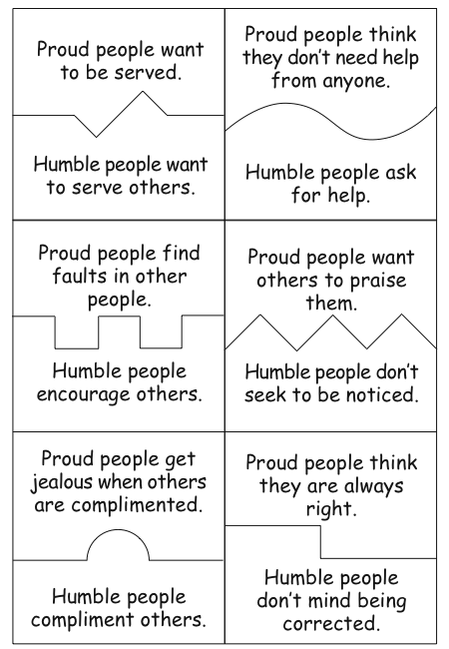

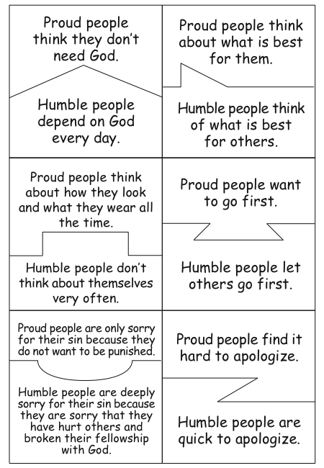

© 2007 BibleLessons4Kidz.com All rights reserved worldwide. May be reproduced for personal, nonprofit, and non-commercial uses only.

