The Fiery Furnace
Daniel 3

“I Will Serve God” Necklace
Just as we saw God use this huge trial to show His faithfulness and to make His name be praised, God may allow trouble in your life for the same reason. The great news is God is FAITHFUL! Just like Shadrach, Meshach and Abednego, you may learn something new and wonderful about the Lord that you didn’t know while you were standing outside the furnace. Daniel 3:17, our Key Bible Verse, reminds us, “We may be thrown into the blazing furnace. But the God we serve is able to bring us out of it alive. He will save us from your powerful hand.”
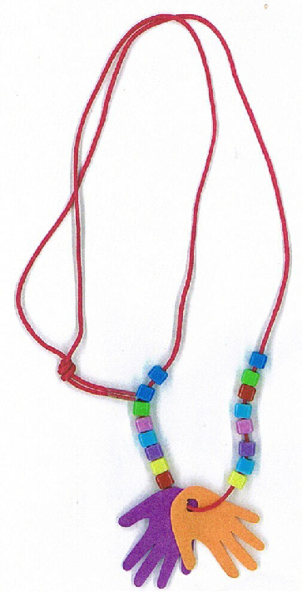

Directions:
- Choose a Necklace kit (www.guildcraftinc.com, #353-448)
- Write “Daniel 3:17” on one of the hands with a marker
- Wear your necklace as a reminder of who you serve and how good He takes care of you!
The Fiery Furnace
Daniel 3

Shadrach, Meshach and Abednego Craft
Shadrach, Meshach and Abednego were determined
not to sin against God. They would NOT worship
anything but the one true God. They knew that
they were defying the King’s order and they WOULD be thrown into a blazing furnace. Yet, the men stood firm. They had decided ahead of time to follow God.
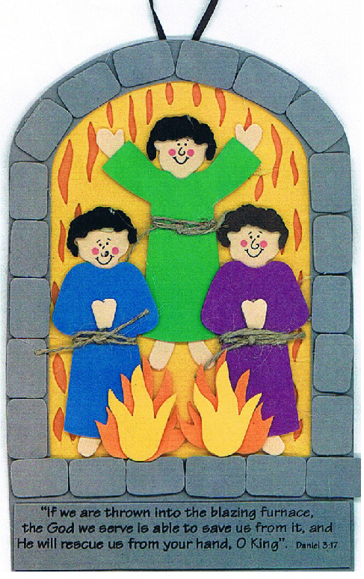

Directions:
- Choose a craft kit (www.orientaltrading.com, 48/2526)
- Using glue dots or tacky glue, glue craft together according to the enclosed directions
- Add the Main Point sticker (God is faithful) to back of completed craft

