Wise and Foolish Builders
Matthew 7:24-27

Main Point: Build your life on the solid Rock of Jesus Christ and His Word.

Key Verse: “Don’t just listen to the Word. You fool yourselves if you do just that. You must do what it says.” James 1:22

Craft Idea

“God at Work” Frame
Foam Picture Frame, www.discountschoolsupply.com, #EVAFK.
- Decorate frame with foam letter stickers and foam tool shapes.
- Print Key Verse onto Avery address labels #5160 and apply to craft.
A similar craft may be purchased: God at Work Frames, www.guildcraftinc.com, 353-441

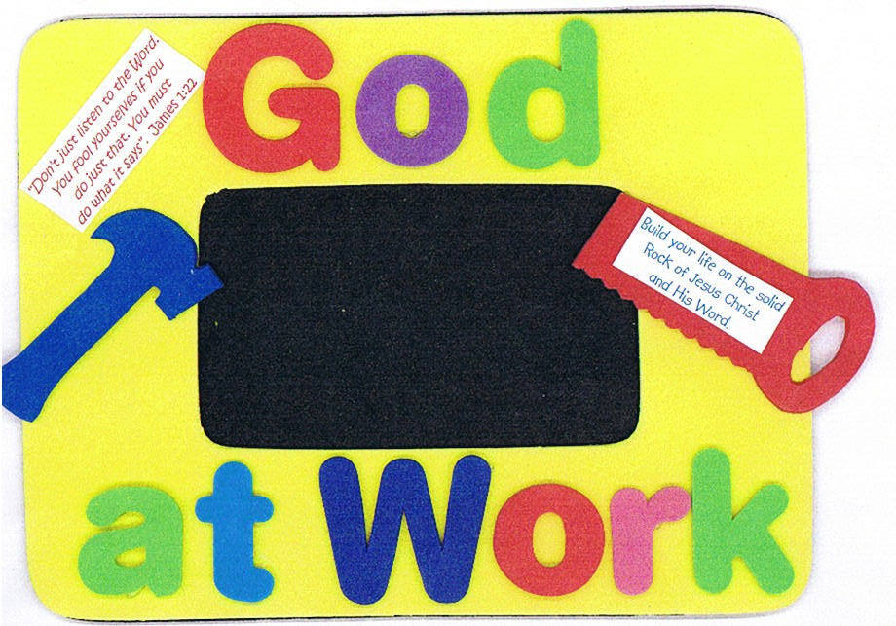

“Build with Jesus” bags, www.orientaltrading.com, 36/1268

