The Armor of God
Ephesians 6:10-17

Main Point: Through Jesus, God has provided everything we need to stand against the devil’s plans.

Key Verse: “Put on all of God’s armor. Then you can stand firm against the devil’s evil plans.” Ephesians 6:11

Craft Ideas

“Armor of God” picture
Supplies Needed: copies of “Armor of God” picture, crayons, colored pencils, markers.
- Make copies of coloring picture.
- Print pieces of armor, using a dot-to-dot font and add to picture.
- Color picture, using markers, crayons, or coloring pencils.
- Print Key Verse onto sticker address labels, Avery #5160 and apply to front of craft.
- Let children use a marker or pen to connect the dots, finishing the specific armor.

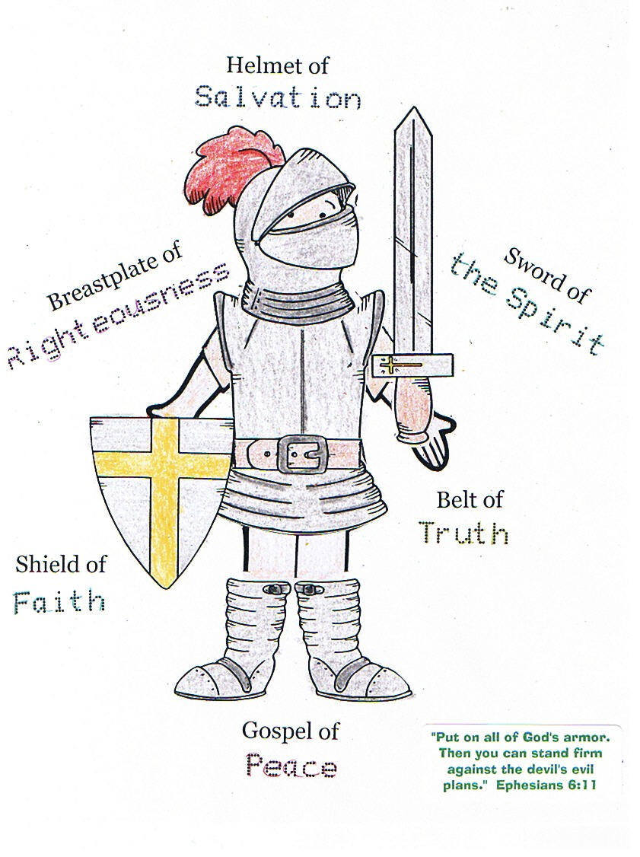

“Armor of God” magnet
Round magnets, www.orientaltrading.com, #57/9503
Armor of God stickers, www.carsondellosa.com, #CD-5285
- Snap apart magnet.
- Print Key Verse onto Avery label, #5160 and apply to one side of circle insert.
- On other side of circle insert, decorate a background.
- After background is complete, add armor stickers. Add words, using permanent markers.
- Snap completed craft magnet back together.

