JUDGES INTRODUCTION
Judges 1 - 3

MAIN POINT: We must each have a relationship with God.

KEY VERSE: After that generation died, another grew up who did not acknowledge the Lord or remember the mighty things he had done for Israel. They abandoned the Lord, the God of their ancestors, who had brought them out of Egypt. Judges 2:10, 12

CRAFT IDEAS

“Jesus Rescues Me” Bracelet
Faith Beaded Cross Bracelet Craft Kit www.orientaltrading.com
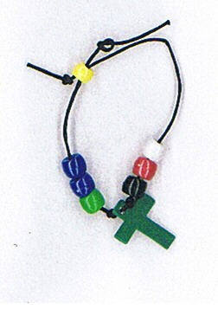
48/1433

“I Am a Friend of God” Bracelet
Slap Bracelet www.orientaltrading.com 57/6532
- Write “I am a friend of God” on the front of bracelet. Decorate
bracelet with permanent fine point markers.
- Print the following Bible Verse onto Avery white mailing labels #5160: And if you search for him will all your heart and soul, you will find him. Deuteronomy 4:29 and apply to back of bracelet.
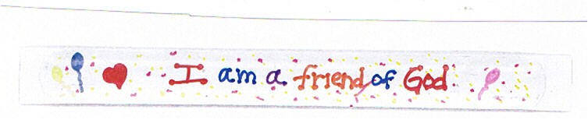

Craft Preparation Idea
- Print Main Point and Key Verse onto Avery white mailing labels
#5160 and apply to sandwich zip lock baggie.
- Place individual crafts in baggies. Keeps crafts easy to grab and make, easy for taking craft home, and connects the craft to the lesson through reminder of Main Point and Key Verse.

