Jonah Flees From the Lord
“Big Love!” Fish Bag Puppet
God pursues you because of His
overwhelming love for you!

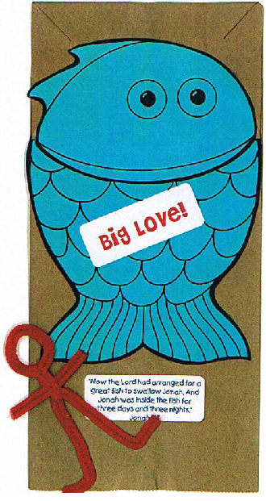

Directions:
- Grab and paper bag, a Jonah pattern, one long piece and one short piece of pipe cleaner
- Cut around Jonah fish pattern with scissors
- Glue top part of fish on the bottom of the paper sack (the bottom box), right to the edge
- Glue bottom of fish right up against the fold
- To make Jonah, twist a loop in the middle of the long piece of pipe cleaner. Add more twists.
- Put the short piece of pipe cleaner across the twisted long piece, to make the arms. Twist the long piece tightly around it.
- Make a few more twists. Separate the two sides to form the legs.
- Add a “Big Love!” sticker
- Add a Key Bible Verse (Jonah 1:17) sticker

Jonah Flees from the Lord
“Big Love!” craft
God pursues you because of His
overwhelming love for you!
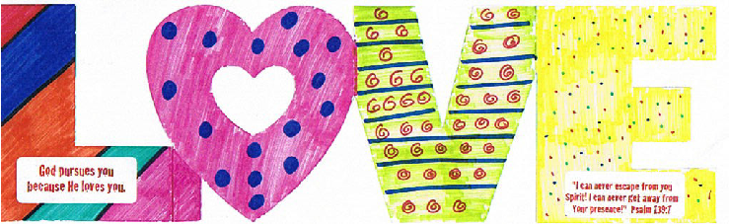

Directions:
- Choose a LOVE card, www.orientaltrading.com, 57/6681
- Decorate with markers
- Add Main Point sticker: “God pursues you because He LOVES you!”
- Add Key Bible Verse sticker: Psalm 139:7
- Stand up your BIG LOVE card at your home and remember that God’s love for you is BIG!

