CREATION
Genesis 1:1 - 2:7

MAIN POINT: God created the world and everything in it to make His glory known.

KEY VERSE: For ever since the world was created, people have seen the earth and sky. Through everything God made, they can clearly see His invisible qualities - His eternal power and divine nature. So they have no excuse for not knowing God. Romans 1:20

CRAFT IDEA

Creation Planter
Garden Of Eden Craft Kit www.ssww.com RE208
Print Main Point (God loves us and created our beautiful world)
onto Avery white mailing label #5160. adding a clip art picture.

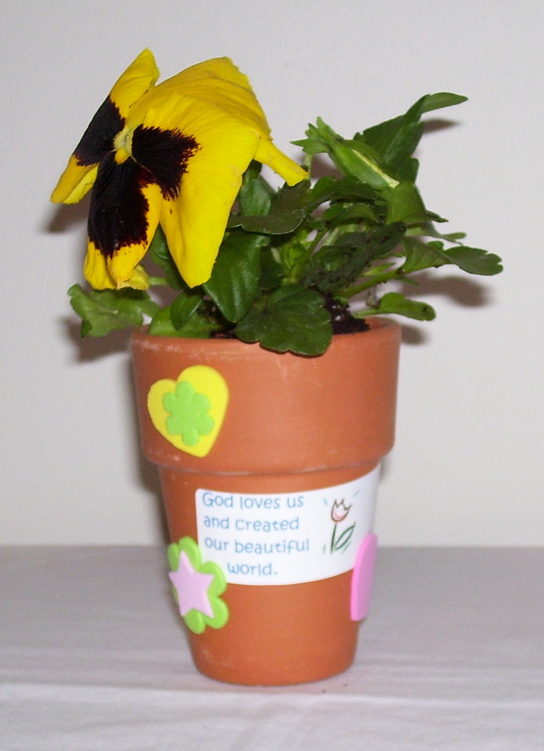
Easy Take Home Bag
Print directions to care for plant onto address sticker label,
Avery #5160. Print Key Verse onto Avery white mailing label as well.
Apply to brown or white craft #2 bag, purchased from Sam’s Club.
Place completed Creation Planter into bag. Fold down the top
edges for an easy and clean way to take craft home.

Make this craft yourself, using a flower pot, a plant or seeds, stickers and labels.

